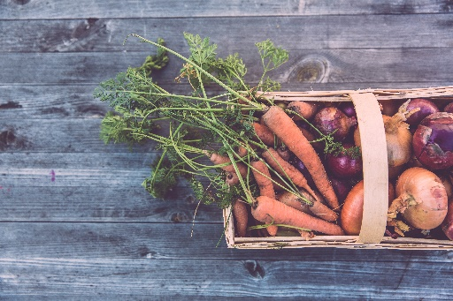

Nutrition 101 resource page

Dr. Kaitlyn N. Staal, ND, MSAc

January 2019

1. PFC’s/PFA’a and other ENDOCRINE DISRUPTORS: Environmental Worker’s Group <https://www.ewg.org/research/dirty-dozen-list-endocrine-disruptors>
2. Clean 15/Dirty Dozen: Environmental Worker’s Group <https://www.ewg.org/foodnews/>
3. Filtered Water options: Environmental Worker’s Group <https://www.ewg.org/tapwater/water-filter-guide.php>
4. MUFAs, PUFAs, Healthy and unhealthy fats: MedIndia <https://www.medindia.net/patients/lifestyleandwellness/mufa-and-pufa-foods.htm>
5. Primary Sources of Saturated Fat: The Spruce Eats <https://www.thespruceeats.com/main-sources-of-saturated-fat-2246228>
6. The Mediterranean Diet: DxLine <http://dxline.info/diseases/the-mediterranean-diet#>
7. Mediterranean, DASH Top US News Best Diets List: Medscape
8. Blood type Diet: Dr. Peter D’Adamo <https://dadamo.com/txt/index.pl?0000>
9. Health Benefits of Grass Fed: Eat Wild <http://www.eatwild.com/healthbenefits.htm>

Dr. Kat

where Science and Spirit meet

Leaves


Kaitlyn N. Staal, Naturopathic Physician

www.drkat.us

Phone: 860-271-7354 • Email: office.drkat@gmail.com